The Right to Food in the World-System

Margaret Clark

International Affairs 4700

Valentine Moghadam

Northeastern University

April 22, 2024

The Right to Food in the World-System

**Abstract**

This paper investigates the adoption patterns of the right to food as national policy from a world-systems perspective. Utilizing world-systems analysis and existing world-systems data assessment tools, along with data visualization tools and Python programming for data analysis, this work produces the Systems of the World Economy Python Tool (SWEPT). The study delves into varying levels of commitment nations make towards establishing the right to food, from adopting international multilateral treaties to building progressive food security assurance networks within state constitutions. A case country analysis includes studies of Kenya, Brazil, and the United States of America to examine their food security environments and adoption of progressive food security frameworks. Data sources such as the World Bank and the FAOlex database are utilized to track income and policy adoption trends. The study contributes to understanding the intersection of global food security policies with economic and political structures within the world-system. It sheds light on patterns of policy adoption and their implications for human rights and international relations.

**Introduction**

In this work, I explore patterns of adoption of the right to food as national policy from a world-systems perspective. There are varying levels of commitment a nation can make to establishing the right to food, which range in three levels: adopting international multilateral treaties, such as ICESCR (The International Covenant on Economic, Social and Cultural Rights), including the right to food within a national constitution, and finally, building frameworks within the state constitution which define progressive and holistic food security assurance networks. Extant literature has thoroughly studied the diffusion of the right to food as a cultural norm through the eyes of world polity theory. Through the lens of world-systems analysis, I seek to explore connections between core, semi-periphery, and periphery identities across the world and assess their corresponding level of progressive food framework adoption. This will be an aggregated quantitative assessment of policy adoption, expanded on by a case study qualitative perspective through a world-systems analysis. I intend to describe the application of world-systems analysis and world polity theory. I will use these to develop three country studies of interesting cases to study their food security environment. I expect to see patterns of adoption of the right to food compared to country positions in the world-system, and more specifically, I expect to see that semi-peripheral countries adopt more advanced food security frameworks. Salvatore Babones (2005) developed a tool to assess Systems of the World Economy, or the SWE Tool, which provided the process for the development of the tool in this work, the Systems of the World Economy Python Tool (SWEPT). Babones studied the zonal changes of nations between 1976 and 2002. Shortly after in 2004, FAO (Food and Agriculture Organization) adopted the Voluntary Guidelines to Support the Progressive Realization of the Right to Adequate Food in the Context of National Food Security. This led to widespread expansion of constitutional adoption of the right to food, especially the improvement of existing structures. The end of his study through the following two decades provides the timeframe for this paper. Final graphical representation and statistical analysis reveals how the contemporary world-system tracks patterns in food rights adoption. In its analysis, I argue that countries in middle economic branches tend to develop more advanced policies for the right to food, and the benefits of doing so lessen as they enter the core.

**Literature Review**

The main concept presented in this work is to analyze the implications of the economic world order on the development of food as a human right. The study is based in two major frameworks: world polity theory, and more crucially, world-systems analysis. These provide the lens with which to understand policy surrounding the right to food.

The right to food was acknowledged in the 1948 Universal Declaration of Human Rights as part of the entitlement to a satisfactory standard of living and is legally protected in the 1966 International Covenant on Economic, Social and Cultural Rights. ICESCR is included in full in Appendix A. The right to food is additionally safeguarded by regional agreements and national constitutions. Every individual, regardless of their race, gender, language, religion, political beliefs, nationality, social background, wealth, birth status, or other circumstances, has the entitlement to sufficient food and the freedom from hunger. During the World Food Summit organized by the Food and Agriculture Organization (FAO) in 1996, nations committed to reducing the number of undernourished individuals by 2015. They also called for clarifications on the responsibilities related to the right to food outlined in international human rights law. In 2004, the FAO adopted the Voluntary Guidelines to Support the Progressive Realization of the Right to Adequate Food in the Context of National Food Security, offering practical advice to nations in implementing the right to adequate food (OHCHR, 2010). To understand food policy motivations, I must first define the right to food.

Food policy often falls under the umbrella of human rights, intermingling the status of food security and human security. Based on the 1996 World Food Summit, food security is when all people, always, have physical and economic access to sufficient safe and nutritious food that meets their dietary needs and food preferences for an active and healthy life. Human security establishes the entitlement of every individual to live in liberty and respect, devoid of impoverishment and hopelessness. It affirms that all persons, especially those in vulnerable situations, should have freedom from both fear and deprivation, along with equal access to their rights and the ability to live a full life. In constitutional commitments to human security, states may include the right to food or nourishment, and these references are considered constitutional mentions in this work. International treaties, such as the ISESCR (The International Covenant on Economic, Social and Cultural Rights), informed state policy development around food, and at bare minimum recognition of the right to food, most nations have ratified it.

Hafner-Burton and Tsutsui (2005) describe the state of human rights policy and how it reflects positive change, assessing human rights in global treaties. The ICCPR (International Covenant on Civil and Political Rights) includes the right to life. The CAT (Covenant Against Torture) is less applicable to state food legislation in this context. The CRC (Convention on the Rights of Children) ensures access to nutritious food. CEDAW (Convention on the Elimination of All Forms of Discrimination against Women) offers women nutrition only explicitly during pregnancy. The CERD (Committee on the Elimination of Racial Discrimination) promises social services and security (OCHR, 2024). Despite food access quality being a major determinant of health and happiness, it is not always explicitly mentioned. I focus on ratification of the ICESCR. They argue first that countries ratifying human rights laws does not always correlate to them adopting them, and often allows a loose framework which does not need to be strictly adhered to, protecting repressive practices. Second, the true adoption of human rights laws occurs through human rights activism mobilizing around these laws and encouraging true global standards for human rights. This true adoption is described in their finding that states whose citizens belong to a greater number of INGOs are more likely to protect the rights of their citizens. They draw on world society theory in its argument that international non-governmental organizations impose independent global civil society effects which promote the actual adoption of human rights. They pull a variety of economic factors, political factors, and demographic factors theorized to influence the adoption of human rights regimes and study their effectiveness. This is determined through statistical analysis of the adoption of international human rights laws by countries as well as patterns of government repression from 1976 to 1999. They introduce state ratification of various international human rights laws as variables. Their analysis shows that governments have incentives to ratify human rights agreements they have neither the intention nor the capacity to implement, and a lack of economic resources breeds conflict and human rights violations. They find that economic ties with the United States and other advanced capitalist states encourage human rights violations in the periphery, democracies are less like to commit human rights abuses, conflict countries are more likely to commit human rights abuses, and rapid population growth encourages authoritarian governance and thus the revocation of human rights.

For food policy, developing it as extensive frameworks promoting sustainable food systems with best governance practice are more effective than brief mentions of the right to food. Half of all developing countries did not have publicly available nutrition policies seven years ago. Rates of obesity and diet-related conditions, side effects of poor food access and poor food policy, have continued to rise in high-income nations and reduces achievements of development goals (Lee et al., 2020). The international networks which influence food policy are at a much larger unit of analysis than a nation, and both cultural and economic factors play a role in them.

**World Polity Theory**

Though not the focus of this work, world polity theory is important to present the implications of the cultural world order on the development of food as a human right. Bas Kierkels developed an exceptionally complete assessment on the progress of the right to food through a world polity analysis. Kierkels argued for the prevalent influence of the cultural world order on the dissemination of the right to food. He especially pointed to international non-governmental organizations (INGOs) for their effect on state adoption. Policy and treaty inform his understanding of transnational relationships where human rights focused organizations are prominent actors. He details the isomorphic influence of leaders in the global world order on less powerful states which encourage the adoption of different human rights regimes. The correlation between international organizations, especially non-governmental ones, and the development of universal standards is central (Kierkels, 2010). However, as such an extensive piece, there is a great deal of background unnecessary to my level of study, such as analyzing the historical formation of the United Nations and INGOS. The inclusion of these organizations is crucial to their neo-institutionalist perspective on World Polity Theory. Kierkels’s methodology is overall an extensive literature review, with heavy policy analysis and discourse analysis. I find their work to be exceptionally thorough which will aid my basis for exploring the extant literature. This perspective undoubtedly has a considerable influence on adoption of right to food policy and aided in my identification of my three benchmarks. However, Kierkels supposes the liberal market is limited in ensuring human rights policy development and limits his study perspective through a world polity framework. There is a lack of quantitative analysis, and this work is slightly dated. Kierkels also acknowledges limitations of World Polity Theory in explaining global structure. Boli and Thomas argued similarly that world culture exists and is shaped by INGOS. For world-systems analysis, they stated it left state actors as unanalyzed givens rather than constructed players to on a hierarchical playing field of the world polity. To have international cultural standards, such as human rights policies, is to be a recognized state in the world polity, and thus, connection to the powers of legitimacy. World culture provides the identify, the self, which guide the behavior of global actors (Boli and Thomas, 1997). In this analysis, world culture exerts influence within a framework of world-systems analysis.

**World-Systems Analysis**

World-systems analysis is the axis of this work, as it is defined by Salvatore Babones in “The Country-Level Income Structure of the World-Economy.” He describes it as a relatively stable trichotomous structure reflecting what was presented in Wallerstein’s earlier 1974 work, *Modern World-System, Volume I.* Wallerstein’s three-zone structure of the world-system, in which a system of the world. Wallerstein posits that in a capitalist world economy experiencing modernization, states develop on a predictable linear path where each zone reflects a stage of industrialization, urbanization and secularization and denotes attributes and power relationships. In world-systems analysis, the core, periphery, and semi-periphery zones represent distinct levels of economic development and influence within the global economy. The pivotal unit of analysis, rather than being states themselves, is a globally connected economy, or, as first put forth by Fernand Braudel, the “économie-monde” (Babones and Chase-Dunn, 2012). Core zones refer to the most economically developed and technologically advanced regions in the world. They often dominate global trade, finance, and innovation. These areas typically have elevated levels of industrialization, advanced infrastructure, and a concentration of wealth and political power. The periphery zones are the least developed and economically disadvantaged regions in the global economy. These areas often rely on primary industries like agriculture, mining, and low-skilled manufacturing. They tend to have less access to advanced technology and weaker influence on the global stage. Wallerstein’s analysis also offered the notable mid-range zone of semi-periphery to the core and periphery zones. The semi-periphery occupies an intermediate position between the core and periphery zones. These states exhibit characteristics of both advanced and developing economies. They may have growing industrial sectors, moderate technological capabilities, and a higher degree of influence but not to the extent of core countries. Examples of semi-peripheral countries include China, India, and some Eastern European nations. Wallerstein traces the semi-periphery zone incorporation into the system to periphery countries’ industrialization and contribution of production labor and resources to core countries, where primary industries wane due to core capitalist development. As developing countries urbanize and their resources exhaust, they become less viable options as cheap labor and resources sources for core countries. These relationships have developed and changed as advancements in technology have contributed to increased long-term globalization. Some world-systems scholars argue the contemporary world economy is entering a period a of deglobalization because of capitalist neoliberalism, economic degradation, and uneven development. These factors produce a less connected, multipolar world economic and political structure, intensified by global awareness of inequalities between the most developed and the least developed states (Chase-Dunn et al., 2023). John Mellor noted evidence of deglobalization in studying food policy, finding that developing countries, in order to protect their food security, will decrease agricultural prices and discourage the growth of their agricultural exports, discouraging international involvement. He argued that to effectively combat food insecurity, developing countries needed to progress national food and income policy (Mellor, 1978). This offers evidence to a relationship between the two and their significance to the larger world economy.

Zone identities of the world-system are based on international trade flow relationships and systemic labor divisions shaped by world-system hierarchies. The ideal indicators used to differentiate zones for analyzing the world-economy and the mathematical or statistical strategies to understand them are contested. Most world-systems analysis performs data-intensive studies of international trade flows. Babones countered with a data analysis tool for analyzing the world-economy which relied on publicly accessible global state income statistics (Babones, 2005). His Structure of the World Economy (SWE) Tool offers easy replication of a software tool to quickly produce a world-economy structure using the more recent data and computing technology from publicly available World Bank World Development Indicators. National income is specifically operationalized in his work in three forms of raw data: gross national product (GNP) per capita, purchasing power parity (PPP), and real local currency (RLC). These indicators, combined with national population data, are loaded into histograms reflecting “bins” of a distribution of income levels across the world-economy. In order to establish perimeters of the world-system zones, peaks and troughs are identified to establish the tri-modal distribution of country incomes. His strategy offers a more direct methodology with acknowledgement of changes in zonal positions over the course of his 30-year period of study. His tool is mimicked in my methodology below but reformatted for Python, along with additional statistical findings.

**Methodology**

In this world-systems study, I developed a tool to reflect both the spirit and process of Babones. The System of the World Economy Python Tool (SWEPT) is similarly customizable, reflective of modern data visualization and analysis strategies, and mimics the Babones SWE Tool (Babones, 2005). Python offers a wide array of tools to draw conclusions from data, allowing users even more flexibility to produce the world-system zonal structure and learn more from its allotments. I pulled policy adoption data from the FAOlex, a database managed and produced by the Food and Agriculture Organization which tracks global recognition of the right to food (FAO, 2021). To take a closer look at the progression of state policies and state food security, I selected three case study countries to analyze further: Kenya, Brazil, and the United States of America. I chose these countries to represent a variety of income situations, geographical region, and policy adoption. It is my hope that these selections and a further assessment of their national food access situation sheds light on broader global patterns. The full code is available in Appendix B of this work.

I first drew from the World Bank Development Indicators website the adjusted net national income (in current U.S. dollars) and the national population of all countries belonging to three regions: North America, Latin America and the Caribbean, and Sub-Saharan Africa. I reduced my perspective to a selection of regions and to a single income indicator rather than the entire world and the three chosen by Babones to enhance the effectiveness of my qualitative review. These regions include examples from all three economic zones, providing an array of upper, middle-, and lower-income nations, as well as a variety of levels in adoption of the right to food for effective analysis. Adjusted net national income is a reliably available metric for study and using one indicator simplifies the tool; users can adjust to their preferred metric. This would change the visual representations, but the process is replicable for other income indicators. Regional limitations reduced the size of my quantitative study to 93 nations. I then performed data cleaning to remove countries with insufficient data and remove missing entries, paring this study to 74 nations. I pulled data between 2001 (one year before the end of Babones’s review) and 2021, the most recent year with complete data for most nations from the World Bank. Thus, I can compare the early years of my zonal allotments with those of Babones, as well as understand state changes throughout the two decades. The Python Pandas library allows me to load the data into DataFrames, which are manipulatable tables. I calculated each country’s income per capita in 2001, 2006, 2011, 2016, and 2021 at five-year intervals, represented as histograms in log10 form for interpretability, as Babones does, to allow users to identify changes in the distribution of the world-economy over the course of the study. Histograms are chosen for their ability to show frequency distribution. Following the histogram visualization, I determined peaks and troughs to serve perimeter-defining purposes in the world-economy income distribution. I utilized the SciPy library’s find_peaks tool. The deepest troughs, and the peaks between them, communicate the relative frequency of the given income value, helping determine the perimeters of the core and the periphery. Relying on peaks and troughs is a much more accurate method than an even division of zones as it is more reflective of the natural structure of the world-economy.

After determining the perimeter of the periphery and the perimeter of the core, I use my code_income function to assign each country as either periphery, semi-periphery, or core, based on their income per capita in relation to the perimeters. This is done for both 2001 and 2021. For comparison with rights adoption, countries also receive a level of one, two, or three based on their income. Higher incomes are associated with higher numbers, meaning periphery countries are coded as one, semi-periphery countries are coded as two, and core countries are coded as three. This DataFrame is then merged with a “Right to Food Adoption” DataFrame. The latter is coded manually, using my current list of countries compared against data from the Office of the United Nations High Commissioner for Human Rights (OHCHR) and the Food and Agriculture Organization’s “FAOLEX”, which keeps track of state commitments to the right to food. From the benchmarks provided by this data trend observation, I determined a scale in which countries receive a score on a scale of zero to three, where a zero suggests no known right to food, a one sets their commitment at the level of ratification of multilateral treaties alone, a two means the right to food is included explicitly or implicitly in their constitution, and finally, a three denotes that not only is the right to food included in their constitution, but also there is a dedicated framework law to the structure of the national food system and directives promoting national food security. These benchmarks encompass the potential state commitments to food security, exclusive of indirectly supportive legislation such as human security.

The final merged DataFrame (final_df) is in Appendix B and used to create a layered bar graph (using the Matplotlib library) depicting the relationship between country placements in the world-system and their level of adoption of the right to food. Bar graphs are useful for comparing categorical datasets, and with my normalization of two standardized variables, comparison is simple. Through standardization, a specific range prevents certain features from dominating the learning process due to different scales. The full dataset is below in three parts, each depicting one of three yellow-cast case studies, to offer more easily interpretable charts. Also below, having informed the production of the bar graph, are two histograms of this world-economy of three regions produced by the SWEPT tool. The histograms cannot be expected to be exactly similar as Babones handled different country data and provided a histogram not for 2001 but 2002, however the distribution is highly similar. Histograms for 2006, 2011, and 2016 are available in Appendix B and offer potential for further analysis on incremental zone changes over time. For the purposes of this work, 2001 was most important for establishing accuracy to Babones’s methodology as well as a baseline for comparison with 2021. Data from 2021 serves as the final state of food policy and income distribution, as presented in the bar graph.

**Discussions, Conclusions, and Charts**

This discussion produces the histograms, peaks and troughs visualizations, bar charts, and statistical findings developed in this work and their analysis. Case study country analysis sheds light on the food access changes from food policy adoption over time and corresponding fluctuations to the world-systems zones and experiences.

Figure 1 | 2001 Distribution of Log10 World Income Per Capita

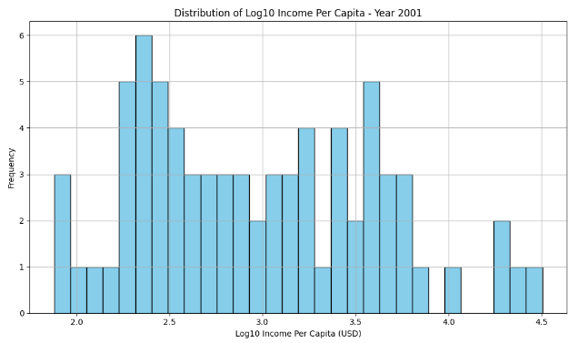

Figure 2 | 2021 Distribution of Log10 World Income Per Capita

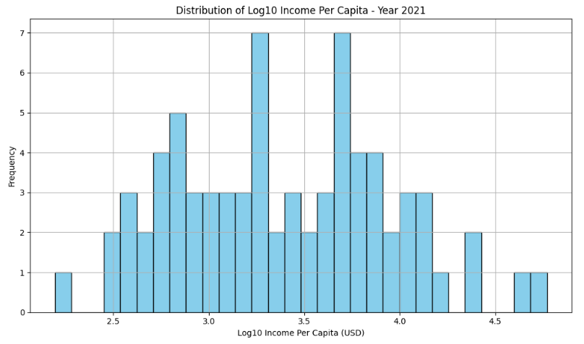

The above histograms represent the frequencies of various income levels across the limited world-economy. The 2001 distribution reflects similarity to the Babones 2002 histogram for log10 of income per capita. While not an exact comparison, this supports the credibility of the process. Significant inequalities are apparent between the upper and lower classes, and the world-economy is evidently divided into a trimodal distribution, defined by various peaks and troughs. Statistical representation of these peaks and troughs and further analysis are provided below.

Figure 3 | Peaks and Troughs in 2001 Distribution of World Income per Capita

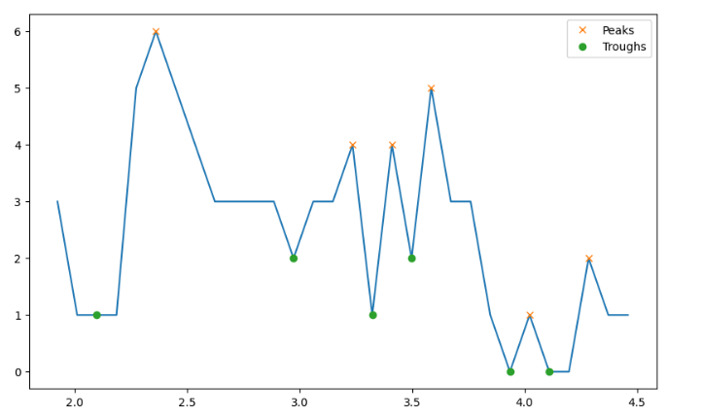

Figure 4

Figure 4 | Peaks and Troughs in 2021 Distribution of World Income per Capita

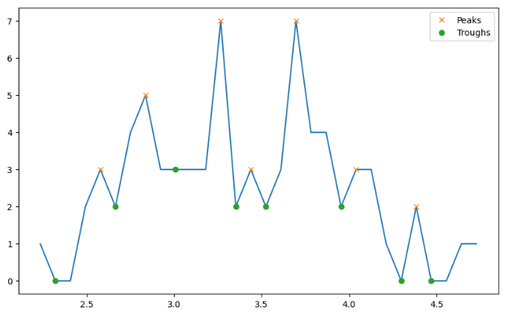

Python is especially useful for identification of peaks and troughs; there are many ways to represent these points, but the above format is both simple to decipher and to produce. The tool find_peaks also provides the exact values of the peak and troughs points, included in Appendix B code. The find_peaks function is part of the scipy.signal module in Python. It is used to detect peaks in data arrays. When applied to a dataset, find_peaks identifies the local maxima that represent peaks in the data based on specified parameters such as peak height, prominence, width, and distance, relating to the frequency of incomes in the world-economy. From observation of the two years, overall income of the world has increased, with both the periphery perimeter and the core perimeter growing from 2001. As reflected in the histograms, the peaks and troughs graphs seem to reflect a normalization shift of the world-economy from 2001 to 2021, developing a shape more resembling a bell curve. Normal distribution suggests the higher and lower ends of world-economy incomes are at more symmetrical distances from the mean. This may be reflective of higher income equality, but significant differences are still present. Further analysis of more income indicators would advise findings on income inequality and are outside the scope of this work. Normal distribution also suggests that data points are independent of one another; this shift may be evidence of deglobalization in the modern world-system where country incomes are less interconnected. The larger frequency of countries falling in around the mean could suggest more countries industrializing and moving into semi-peripheral territory since 2001. We can also observe a larger separation of the highest income nations with their closest neighbors to the left, suggesting there is a growing gap among countries lying comfortably in the core and those at the lower perimeter of the core or the semi-periphery high perimeter. Potential deglobalization or changes in the relative incomes of states could affect their policy for the right to food.

Below are the stacked bar charts developed to reflect the relationship income zone placements and policy progression of the right to food.

Figure 5 | Placement in the World-System vs. Level of Adoption of Right-to-Food Policy

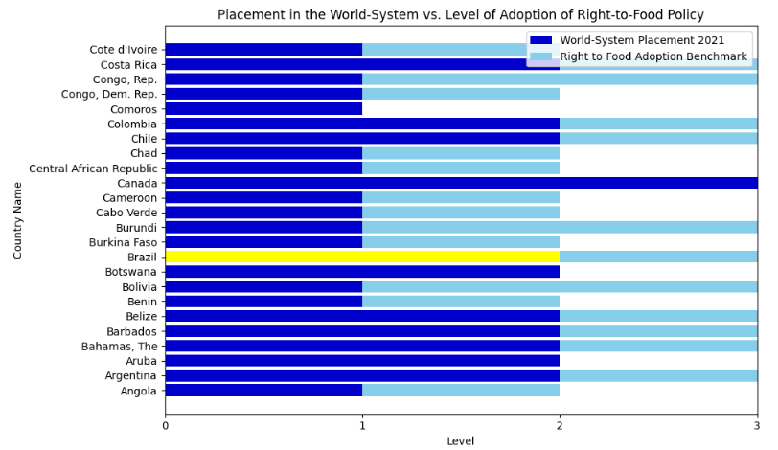

Figure 6 | Placement in the World-System vs. Level of Adoption of Right-to-Food Policy

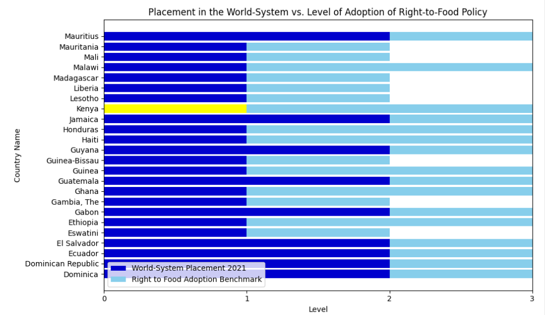

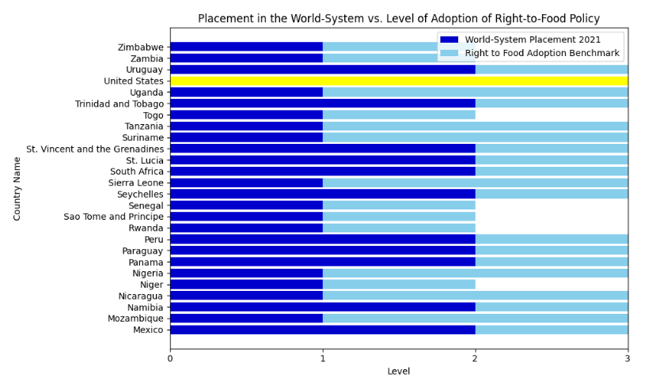Figure 7 | Placement in the World-System vs. Level of Adoption of Right-to-Food Policy

I also performed mathematical analysis on the final DataFrame to pull more insights from the bar chart data. By calculating the total countries coded for each income level and their corresponding rights adoption levels, I determined percentages for adoption in different zones. Of the periphery countries, 2% had no known right to food, 57% had only ratified multilateral treaties, 24% had a constitutional mention, and 17% had developed a framework law. Of the semi-periphery countries, 7% had no known right to food, 47% had only ratified multilateral treaties, 13% had a constitutional mention, and 33% had developed a framework law. Of the core countries, 50% had no known right to food and 50% had at most ratified multilateral treaties, which refers to the United States and Canada, respectively. This is a low data pool for the core countries; however, it does suggest that more developed adoption methods were less likely for higher income countries. Semi-periphery countries had the highest percentage of framework law and secondarily ratified multilateral treaties, while periphery countries tended to either have only ratified treaties or included a mention of the right to food in their constitution. World-systems analysis suggests semi-periphery countries possess a mixture of core and periphery attributes, which is reflected by these statistics. Developing a higher income seems to correlate with developing more advanced framework law, but this pattern collapses for the core countries. This suggests that core countries may not have as much to gain from developing more progressive food security legislation. There is a wide assortment of countries in different regions adopting advanced food policies.

**Case Countries**

**Kenya**

Kenya is a consistently peripheral country in Sub-Saharan Africa. It has both ratified international agreements and possesses an explicit reference to food policy in their constitution. Food policy developed in Kenya making an appearance in its new constitution in 2010 (FAO, 2024). Kenya’s overall income has increased throughout the two decades, but they have yet to break peripheral status. Their food insecurity rate is the highest of the case countries at 28%, and it is strongly driven by climate shocks, agricultural challenges, and inefficient food systems. Their struggling high refugee population, fleeing conflict and disaster in surrounding regions, is exempt from the economy. Debt is a significant blow to their income potential; Kenya’s debt was estimated to have reached 73.2 percent of their GDP in 2023, however this is expected to decline in 2025 (IMF, 2024). Despite setbacks, Kenya is an emerging semi-periphery. Extensive debt owed by countries in the semi-peripheral position or close to the intermediate world-economy zone is a common challenge for less developed countries. Debt owed by less developed states to more developed states is a crucial relationship in the world-economy and contributes to the inequality represented in the histogram distribution. When determining food policy, it may be possible that periphery nations spend more attention and income in other areas such as debt or face greater challenge to achieve food insecurity such as environmental disaster. This prevents peripheral countries like Kenya from being free to build more effective social structures to promote quality food access.

**Brazil**

Brazil represents a Latin American nation solidly in the semi-periphery, based off the Babones assessment. Brazil has seen a great deal of change in their food policy, with an extensive framework for food policy divided into economic sectors. Brazil adopted the Right to Adequate Food into their constitution in 2010 (FAO, 2021). Specific vulnerable groups such as students and workers are identified for support, and the promise of food security for all people is included. Brazil has been experiencing a decline in food insecurity to 8%, prompting its removal from the FAO Hunger Map in 2014 (Arantes Ceolin and Keppe Nogueira, 2023). Mahutga and Smith (2011) observed that countries positioned in the semi-periphery are showing signs of income and productive force alignment with the core nations. Meanwhile, the core is experiencing a stagnation. Brazil’s Ministry of Foreign Affairs, in describing the changes in Brazil’s food policy, directly expresses their desire to be a leader on the global playing field of food security progress. Brazil’s growing income correlated with its developing food policy and the promotion of their innovation is a legitimacy tactic for respect on the world stage. Semi-periphery countries are more likely reign in liberal agriculture trade policies and limit exporting food during periods of global food price increases, whereas countries importing food lessen tariffs to bolster domestic supply (Boratyńska and Raqif, 2017). Semi-periphery distancing from core countries could push them to be more reliant on periphery countries as semi-periphery nations attempt to isolate from the world-economy and protect their nation-state.

**United States of America**

The United States is not only a core country in world-systems analysis, but also considered by many to be the hegemony, which refers to the dominant position in global affairs. This can manifest in economic dominance (e.g., a global economic hegemon), political influence (e.g., a hegemonic superpower), or cultural dominance (e.g., a hegemonic cultural export). They have expressly not developed a right to food, nor have they ratified any international treaties encouraging it. This puts them at a rare zero encoding for the adoption of the right to food, unlike their fellow core country Canada which has at least ratified ICESCR. Their unique stance exemplifies the aggressive autonomy allowed by the hegemon. They are no stranger to food insecurity either; 13% of American are food insecurity. Poverty, unemployment, and low wages are all cited as factors (Drewnowski, 2022). The United States consistently boasts an income separating them from most of the world but resists the social nets they can afford to prevent food insecurity. Their behavior does not support a direct relationship where more income necessarily correlates to more advanced food policy. High income inequality within the nation may contribute food security’s persistence. Food insecurity prevention legislation may also not be focused on economic factors, causing it to underperform. High-income countries apply relatively few economic tools when addressing food system transformation (Lee et al., 2021). My data shows as expected with food policy adoption progressive advancing as income advances, that is, until up until core countries. In the world economy, developing food policy to prevent food insecurity is not necessarily a nonnegotiable task, especially for some wealthier countries, it is not a priority.

As expected, semi-peripheral countries have the most reasoning for pursuing progressive food policy. These findings overall illuminate the network relationships in the world-system. Food security is a challenge for countries across the world-system, but establishing food policy frameworks takes different priorities for different zones. Frameworks are developed across regional barriers. Ratification of international agreements is the most common method of establishing the right to food. Better, more developed frameworks in legislation may contribute to improved food access in a nation. Semi-peripheral nations prioritize developing these frameworks the most and will minimize their interactions in the world economy during periods of challenges to food security.

Future research could explore utilizing other measurements to develop their world-system and produce different distributions. Chase Dunn et al. 2023 presents the utility of network science in representing the world economy, rather than constructing quantitative indicators based on characteristics of nation-states. This could offer a more accurate perspective on the relationships between countries across the zonal structure and contribute findings to their policy development practices. Network depiction software offers a highly interpretable visualization and expands potential findings. Additionally, the right to food is not universally accepted as the most effective to combat world hunger. Its vague identification and weak promise of all people’s autonomy over their food access is criticized, and research has explored terms to expand on the understanding of food access to fight food insecurity (Mowbray, 2007). To study constitutional commitments more in-depth and create a more complex benchmark, state legislation for more progressive descriptions of food access could offer further analysis.

The findings of this study underscore the intricate interplay between economic structures, political dynamics, and human rights considerations in shaping national policies related to food security. As the world continues to navigate complex challenges, such as climate change and economic disparities, understanding how nations position themselves within the world-system and the corresponding implications for food security policies remains crucial. In conclusion, this study contributes to the ongoing discourse on the intersection of economic development, political systems, and human rights by offering a nuanced examination of policy adoption of the right to food. By leveraging modern data analysis tools and theoretical frameworks, we gain a richer understanding of the multifaceted forces shaping our world.

**Bibliography**

Arantes Ceolin, Saulo, and Keppe Nogueira, Luiz Carlos. “Brazil’s Return: Towards Zero Hunger (Again).” Institute of Development Studies Brazil, August 2023. https://www.ids.ac.uk/opinions/brazils-return-towards-zero-hunger-again/.

Arrighi, Giovanni, and Jessica Drangel. “The Stratification of the World-Economy: An Exploration of the Semiperipheral Zone.” Review (Fernand Braudel Center) 10, no. 1 (1986): 9–74. <http://www.jstor.org/stable/40241047>.

Babones, Salvatore. 2008. “Income inequality and population health: correlation and causality.” Soc Sci Med. 2008 Apr;66(7):1614-26. doi: 10.1016/j.socscimed.2007.12.012. PMID: 18222588.

Babones, Salvatore. 2005. “The Country-Level Income Structure of the World-Economy”. Journal of World-Systems Research 11 (1):29-55. https://doi.org/10.5195/jwsr.2005.392.

Barlow, P, R Loopstra, V Tarasuk, and A Reeves. “Liberal Trade Policy and Food Insecurity across the Income Distribution: An Observational Analysis in 132 Countries, 2014-17.” The Lancet. Global health, August 2020. https://pubmed.ncbi.nlm.nih.gov/32710865/.

Boli, John and George M. Thomas. 1997. “World Culture in the World Polity: A Century of International Non-Governmental Organization.” American Sociological Review 62, no. 2 (April): 171–190.

Boratyńska, Katarzyna T, and Raqif Tofiq Huseynov. “An Innovative Approach to Food Security Policy in Developing Countries.” Journal of Innovation & Knowledge 2, no. 1 (2017): 39–44. https://doi.org/10.1016/j.jik.2016.01.007.

Chase-Dunn, Christopher, Alexis Álvarez, and Yuhao Liao. 2023. "Waves of Structural Deglobalization: A World-Systems Perspective" Social Sciences 12, no. 5: 301. https://doi.org/10.3390/socsci12050301.

Chase-Dunn, Christopher, and Peter Grimes. “World-Systems Analysis.” Annual Review of Sociology 21, no. 1 (January 1, 1995): 387–417. https://doi.org/10.1146/annurev.soc.21.1.387.

De Schutter, Olivier. Rep. Countries Tackling Hunger with a Right to Food Approach. United Nations Special Rapportuer on the Right to Food, May 2010.

Drewnowski, A. “Food insecurity has economic root causes.” Nat Food 3 (2022): 555–556. https://doi.org/10.1038/s43016-022-00577-w.

“Frequently Asked Questions on Kenya.” IMF: Kenya, January 17, 2024. https://www.imf.org/en/Countries/KEN/kenya-qandas.

Hafner‐Burton, Emilie M., and Kiyoteru Tsutsui. “Human Rights in a Globalizing World: The Paradox of Empty Promises.” American Journal of Sociology 110, no. 5 (2005): 1373–1411. https://doi.org/10.1086/428442.

Hossain, Md Belal, Michael A. Long, and Paul B. Stretesky. 2021. "Welfare State Spending, Income Inequality and Food Insecurity in Affluent Nations: A Cross-National Examination of OECD Countries." Sustainability 13, no. 1: 324. https://doi.org/10.3390/su13010324.

Kierkels, Bas. “The Evolution of the Right to Food in the Human Rights Paradigm: Human rights in the context of globalization.” PhD diss., Wageningen University and Research Centre, 2010.

Knuth, Lidija, and Margret Vidar. Issue brief. Constitutional and Legal Protection of the Right to Food around the World. Food and Agriculture Organization of the United Nations, 2011.

Lee, AJ, K Cullerton, and LM Herron. “Achieving Food System Transformation: Insights from a Retrospective Review of Nutrition Policy (in)Action in High-Income Countries.” International journal of health policy and management, 2021. https://pubmed.ncbi.nlm.nih.gov/33105968/.

Lee, Amanda J., Katherine Cullerton, and Lisa-Maree Herron. “Achieving Food System Transformation: Insights from a Retrospective Review of Nutrition Policy (in)Action in High-Income Countries.” International Journal of Health Policy and Management, October 19, 2020. https://doi.org/10.34172/ijhpm.2020.188.

Mahutga, Matthew & Smith, David. (2011). “Globalization, the Structure of the World Economy and Economic Development.” Social Science Research. 40: 257-272. https://doi.org/10.1016/j.ssresearch.2010.08.012.

Mellor, John W. “Food Price Policy and Income Distribution in Low-Income Countries.” Economic Development and Cultural Change 27, no. 1 (1978): 1–26. http://www.jstor.org/stable/1153310.

Mowbray, Jacqueline. “The Right to Food and the International Economic System: An Assessment of the Rights-Based Approach to the Problem of World Hunger.” Leiden Journal of International Law 20, no. 3 (2007): 545–69. https://doi-org.ezproxy.neu.edu/10.1017/S0922156507004256.

“Publications | Office of the High Commissioner of Human Rights.” The Right to Adequate Food, April 2010. https://www.ohchr.org/en/publications.

“The Right to Food Around the Globe.” FAOLEX Database | Food and Agriculture Organization of the United Nations, 2021. https://www.fao.org/faolex/en/.

World Bank. "World Development Indicators." The World Bank Group. Accessed April, 2024. https://databank.worldbank.org/source/world-development-indicators.

"World Food Summit, 1996," Palgrave Macmillan Books, in: World Food Security, chapter 35, pages 347-360, Palgrave Macmillan.l Deglobalization: A World-Systems Perspective.” Social Sciences (vol. 12, 301): 1-23

**Appendix Table of Contents**

Appendix A: United Nations ICESCR…………………………………………………………….

Appendix B: SWEPT Code and Outputs……………………………………………………

**Appendix A**

**International Covenant on Economic, Social and Cultural Rights**

**Adopted and opened for signature, ratification and accession by General Assembly resolution 2200A (XXI)**

**of 16 December 1966**

**entry into force 3 January 1976, in accordance with article 27**

Preamble

The States Parties to the present Covenant,

Considering that, in accordance with the principles proclaimed in the Charter of the United Nations, recognition of the inherent dignity and of the equal and inalienable rights of all members of the human family is the foundation of freedom, justice and peace in the world,

Recognizing that these rights derive from the inherent dignity of the human person,

Recognizing that, in accordance with the Universal Declaration of Human Rights, the ideal of free human beings enjoying freedom from fear and want can only be achieved if conditions are created whereby everyone may enjoy his economic, social and cultural rights, as well as his civil and political rights,

Considering the obligation of States under the Charter of the United Nations to promote universal respect for, and observance of, human rights and freedoms,

Realizing that the individual, having duties to other individuals and to the community to which he belongs, is under a responsibility to strive for the promotion and observance of the rights recognized in the present Covenant,

Agree upon the following articles:

**PART I**

**Article 1**

1. All peoples have the right of self-determination. By virtue of that right they freely determine their political status and freely pursue their economic, social and cultural development.
2. All peoples may, for their own ends, freely dispose of their natural wealth and resources without prejudice to any obligations arising out of international economic co-operation, based upon the principle of mutual benefit, and international law. In no case may a people be deprived of its own means of subsistence.
3. The States Parties to the present Covenant, including those having responsibility for the administration of Non-Self-Governing and Trust Territories, shall promote the realization of the right of self-determination, and shall respect that right, in conformity with the provisions of the Charter of the United Nations.

**PART II**

**Article 2**

1. Each State Party to the present Covenant undertakes to take steps, individually and through international assistance and co-operation, especially economic and technical, to the maximum of its available resources, with a view to achieving progressively the full realization of the rights recognized in the present Covenant by all appropriate means, including particularly the adoption of legislative measures.
2. The States Parties to the present Covenant undertake to guarantee that the rights enunciated in the present Covenant will be exercised without discrimination of any kind as to race, colour, sex, language, religion, political or other opinion, national or social origin, property, birth or other status.
3. Developing countries, with due regard to human rights and their national economy, may determine to what extent they would guarantee the economic rights recognized in the present Covenant to non- nationals.

**Article 3**

The States Parties to the present Covenant undertake to ensure the equal right of men and women to the enjoyment of all economic, social and cultural rights set forth in the present Covenant.

**Article 4**

The States Parties to the present Covenant recognize that, in the enjoyment of those rights provided by the State in conformity with the present Covenant, the State may subject such rights only to such limitations as are determined by law only in so far as this may be compatible with the nature of these rights and solely for the purpose of promoting the general welfare in a democratic society.

**Article 5**

1. Nothing in the present Covenant may be interpreted as implying for any State, group or person any right to engage in any activity or to perform any act aimed at the destruction of any of the rights or freedoms recognized herein, or at their limitation to a greater extent than is provided for in the present Covenant.
2. No restriction upon or derogation from any of the fundamental human rights recognized or existing in any country in virtue of law, conventions, regulations or custom shall be admitted on the pretext that the present Covenant does not recognize such rights or that it recognizes them to a lesser extent.

**PART III**

**Article 6**

1. The States Parties to the present Covenant recognize the right to work, which includes the right of everyone to the opportunity to gain his living by work which he freely chooses or accepts, and will take appropriate steps to safeguard this right.
2. The steps to be taken by a State Party to the present Covenant to achieve the full realization of this right shall include technical and vocational guidance and training programmes, policies and techniques to achieve steady economic, social and cultural development and full and productive employment under conditions safeguarding fundamental political and economic freedoms to the individual.

**Article 7**

The States Parties to the present Covenant recognize the right of everyone to the enjoyment of just and favourable conditions of work which ensure, in particular:

* 1. Remuneration which provides all workers, as a minimum, with:
     1. Fair wages and equal remuneration for work of equal value without distinction of any kind, in particular women being guaranteed conditions of work not inferior to those enjoyed by men, with equal pay for equal work;
     2. A decent living for themselves and their families in accordance with the provisions of the present Covenant;
  2. Safe and healthy working conditions; (c) Equal opportunity for everyone to be promoted in his employment to an appropriate higher level, subject to no considerations other than those of seniority and competence;

(d ) Rest, leisure and reasonable limitation of working hours and periodic holidays with pay, as well as remuneration for public holidays

**Article 8**

1. The States Parties to the present Covenant undertake to ensure:
   1. The right of everyone to form trade unions and join the trade union of his choice, subject only to the rules of the organization concerned, for the promotion and protection of his economic and social interests. No restrictions may be placed on the exercise of this right other than those prescribed by law and which are necessary in a democratic society in the interests of national security or public order or for the protection of the rights and freedoms of others;
   2. The right of trade unions to establish national federations or confederations and the right of the latter to form or join international trade-union organizations;
   3. The right of trade unions to function freely subject to no limitations other than those prescribed by law and which are necessary in a democratic society in the interests of national security or public order or for the protection of the rights and freedoms of others;
   4. The right to strike, provided that it is exercised in conformity with the laws of the particular country.
2. This article shall not prevent the imposition of lawful restrictions on the exercise of these rights by members of the armed forces or of the police or of the administration of the State. 3. Nothing in this article shall authorize States Parties to the International Labour Organisation Convention of 1948 concerning Freedom of Association and Protection of the Right to Organize to take legislative measures which would prejudice, or apply the law in such a manner as would prejudice, the guarantees provided for in that Convention.

**Article 9**

The States Parties to the present Covenant recognize the right of everyone to social security, including social insurance.

**Article 10**

The States Parties to the present Covenant recognize that:

1. The widest possible protection and assistance should be accorded to the family, which is the natural and fundamental group unit of society, particularly for its establishment and while it is responsible for the care and education of dependent children. Marriage must be entered into with the free consent of the intending spouses.
2. Special protection should be accorded to mothers during a reasonable period before and after childbirth. During such period working mothers should be accorded paid leave or leave with adequate social security benefits.
3. Special measures of protection and assistance should be taken on behalf of all children and young persons without any discrimination for reasons of parentage or other conditions. Children and young persons should be protected from economic and social exploitation. Their employment in work harmful to their morals or health or dangerous to life or likely to hamper their normal development should be punishable by law. States should also set age limits below which the paid employment of child labour should be prohibited and punishable by law.

**Article 11**

1. The States Parties to the present Covenant recognize the right of everyone to an adequate standard of living for himself and his family, including adequate food, clothing and housing, and to the continuous improvement of living conditions. The States Parties will take appropriate steps to ensure the realization of this right, recognizing to this effect the essential importance of international co- operation based on free consent.
2. The States Parties to the present Covenant, recognizing the fundamental right of everyone to be free from hunger, shall take, individually and through international co-operation, the measures, including specific programmes, which are needed:
   1. To improve methods of production, conservation and distribution of food by making full use of technical and scientific knowledge, by disseminating knowledge of the principles of nutrition and by developing or reforming agrarian systems in such a way as to achieve the most efficient development and utilization of natural resources;
   2. Taking into account the problems of both food-importing and food-exporting countries, to ensure an equitable distribution of world food supplies in relation to need.

**Article 12**

1. The States Parties to the present Covenant recognize the right of everyone to the enjoyment of the highest attainable standard of physical and mental health.
2. The steps to be taken by the States Parties to the present Covenant to achieve the full realization of this right shall include those necessary for:
   1. The provision for the reduction of the stillbirth-rate and of infant mortality and for the healthy development of the child;
   2. The improvement of all aspects of environmental and industrial hygiene;
   3. The prevention, treatment and control of epidemic, endemic, occupational and other diseases;
   4. The creation of conditions which would assure to all medical service and medical attention in the event of sickness.

**Article 13**

1. The States Parties to the present Covenant recognize the right of everyone to education. They agree that education shall be directed to the full development of the human personality and the sense of its dignity, and shall strengthen the respect for human rights and fundamental freedoms. They further agree that education shall enable all persons to participate effectively in a free society, promote understanding, tolerance and friendship among all nations and all racial, ethnic or religious groups, and further the activities of the United Nations for the maintenance of peace.
2. The States Parties to the present Covenant recognize that, with a view to achieving the full realization of this right:
   1. Primary education shall be compulsory and available free to all;
   2. Secondary education in its different forms, including technical and vocational secondary education, shall be made generally available and accessible to all by every appropriate means, and in particular by the progressive introduction of free education;
   3. Higher education shall be made equally accessible to all, on the basis of capacity, by every appropriate means, and in particular by the progressive introduction of free education;
   4. Fundamental education shall be encouraged or intensified as far as possible for those persons who have not received or completed the whole period of their primary education;
   5. The development of a system of schools at all levels shall be actively pursued, an adequate fellowship system shall be established, and the material conditions of teaching staff shall be continuously improved.
3. The States Parties to the present Covenant undertake to have respect for the liberty of parents and, when applicable, legal guardians to choose for their children schools, other than those established by the public authorities, which conform to such minimum educational standards as may be laid down or approved by the State and to ensure the religious and moral education of their children in conformity with their own convictions.
4. No part of this article shall be construed so as to interfere with the liberty of individuals and bodies to establish and direct educational institutions, subject always to the observance of the principles set forth in paragraph I of this article and to the requirement that the education given in such institutions shall conform to such minimum standards as may be laid down by the State.

**Article 14**

Each State Party to the present Covenant which, at the time of becoming a Party, has not been able to secure in its metropolitan territory or other territories under its jurisdiction compulsory primary education, free of charge, undertakes, within two years, to work out and adopt a detailed plan of action for the progressive implementation, within a reasonable number of years, to be fixed in the plan, of the principle of compulsory education free of charge for all.

**Article 15**

1. The States Parties to the present Covenant recognize the right of everyone:
   1. To take part in cultural life;
   2. To enjoy the benefits of scientific progress and its applications;
   3. To benefit from the protection of the moral and material interests resulting from any scientific, literary or artistic production of which he is the author.
2. The steps to be taken by the States Parties to the present Covenant to achieve the full realization of this right shall include those necessary for the conservation, the development and the diffusion of science and culture. 3. The States Parties to the present Covenant undertake to respect the freedom indispensable for scientific research and creative activity.

4. The States Parties to the present Covenant recognize the benefits to be derived from the encouragement and development of international contacts and co-operation in the scientific and cultural fields.

**PART IV**

**Article 16**

1. The States Parties to the present Covenant undertake to submit in conformity with this part of the Covenant reports on the measures which they have adopted and the progress made in achieving the observance of the rights recognized herein.
   1. All reports shall be submitted to the Secretary-General of the United Nations, who shall transmit copies to the Economic and Social Council for consideration in accordance with the provisions of the present Covenant;
   2. The Secretary-General of the United Nations shall also transmit to the specialized agencies copies of the reports, or any relevant parts therefrom, from States Parties to the present Covenant which are also members of these specialized agencies in so far as these reports, or parts therefrom, relate to any matters which fall within the responsibilities of the said agencies in accordance with their constitutional instruments.

**Article 17**

1. The States Parties to the present Covenant shall furnish their reports in stages, in accordance with a programme to be established by the Economic and Social Council within one year of the entry into force of the present Covenant after consultation with the States Parties and the specialized agencies concerned.
2. Reports may indicate factors and difficulties affecting the degree of fulfilment of obligations under the present Covenant.
3. Where relevant information has previously been furnished to the United Nations or to any specialized agency by any State Party to the present Covenant, it will not be necessary to reproduce that information, but a precise reference to the information so furnished will suffice.

**Article 18**

Pursuant to its responsibilities under the Charter of the United Nations in the field of human rights and fundamental freedoms, the Economic and Social Council may make arrangements with the specialized agencies in respect of their reporting to it on the progress made in achieving the observance of the provisions of the present Covenant falling within the scope of their activities. These reports may include particulars of decisions and recommendations on such implementation adopted by their competent organs.

**Article 19**

The Economic and Social Council may transmit to the Commission on Human Rights for study and general recommendation or, as appropriate, for information the reports concerning human rights submitted by States in accordance with articles 16 and 17, and those concerning human rights submitted by the specialized agencies in accordance with article 18.

**Article 20**

The States Parties to the present Covenant and the specialized agencies concerned may submit comments to the Economic and Social Council on any general recommendation under article 19 or reference to such general recommendation in any report of the Commission on Human Rights or any documentation referred to therein.

**Article 21**

The Economic and Social Council may submit from time to time to the General Assembly reports with recommendations of a general nature and a summary of the information received from the States Parties to the present Covenant and the specialized agencies on the measures taken and the progress made in achieving general observance of the rights recognized in the present Covenant.

**Article 22**

The Economic and Social Council may bring to the attention of other organs of the United Nations, their subsidiary organs and specialized agencies concerned with furnishing technical assistance any matters arising out of the reports referred to in this part of the present Covenant which may assist such bodies in deciding, each within its field of competence, on the advisability of international measures likely to contribute to the effective progressive implementation of the present Covenant.

**Article 23**

The States Parties to the present Covenant agree that international action for the achievement of the rights recognized in the present Covenant includes such methods as the conclusion of conventions, the adoption of recommendations, the furnishing of technical assistance and the holding of regional meetings and technical meetings for the purpose of consultation and study organized in conjunction with the Governments concerned.

**Article 24**

Nothing in the present Covenant shall be interpreted as impairing the provisions of the Charter of the United Nations and of the constitutions of the specialized agencies which define the respective responsibilities of the various organs of the United Nations and of the specialized agencies in regard to the matters dealt with in the present Covenant.

**Article 25**

Nothing in the present Covenant shall be interpreted as impairing the inherent right of all peoples to enjoy and utilize fully and freely their natural wealth and resources.

**PART V**

**Article 26**

1. The present Covenant is open for signature by any State Member of the United Nations or member of any of its specialized agencies, by any State Party to the Statute of the International Court of Justice, and by any other State which has been invited by the General Assembly of the United Nations to become a party to the present Covenant.
2. The present Covenant is subject to ratification. Instruments of ratification shall be deposited with the Secretary-General of the United Nations.
3. The present Covenant shall be open to accession by any State referred to in paragraph 1 of this article.
4. Accession shall be effected by the deposit of an instrument of accession with the Secretary-General of the United Nations.
5. The Secretary-General of the United Nations shall inform all States which have signed the present Covenant or acceded to it of the deposit of each instrument of ratification or accession.

**Article 27**

1. The present Covenant shall enter into force three months after the date of the deposit with the Secretary-General of the United Nations of the thirty-fifth instrument of ratification or instrument of accession.
2. For each State ratifying the present Covenant or acceding to it after the deposit of the thirty-fifth instrument of ratification or instrument of accession, the present Covenant shall enter into force three months after the date of the deposit of its own instrument of ratification or instrument of accession.

**Article 28**

The provisions of the present Covenant shall extend to all parts of federal States without any limitations or exceptions.

**Article 29**

1. Any State Party to the present Covenant may propose an amendment and file it with the Secretary- General of the United Nations. The Secretary-General shall thereupon communicate any proposed amendments to the States Parties to the present Covenant with a request that they notify him whether they favour a conference of States Parties for the purpose of considering and voting upon the proposals. In the event that at least one third of the States Parties favours such a conference, the Secretary-General shall convene the conference under the auspices of the United Nations. Any amendment adopted by a majority of the States Parties present and voting at the conference shall be submitted to the General Assembly of the United Nations for approval.
2. Amendments shall come into force when they have been approved by the General Assembly of the United Nations and accepted by a two-thirds majority of the States Parties to the present Covenant in accordance with their respective constitutional processes.
3. When amendments come into force they shall be binding on those States Parties which have accepted them, other States Parties still being bound by the provisions of the present Covenant and any earlier amendment which they have accepted.

**Article 30**

Irrespective of the notifications made under article 26, paragraph 5, the Secretary-General of the United Nations shall inform all States referred to in paragraph I of the same article of the following particulars:

* 1. Signatures, ratifications and accessions under article 26;
  2. The date of the entry into force of the present Covenant under article 27 and the date of the entry into force of any amendments under article 29.

**Article 31**

1. The present Covenant, of which the Chinese, English, French, Russian and Spanish texts are equally authentic, shall be deposited in the archives of the United Nations.
2. The Secretary-General of the United Nations shall transmit certified copies of the present Covenant to all States referred to in article 26.

**Appendix B |** Python code written in Jupyter Notebooks. Code is thoroughly documented for easy user readability and corresponding outputted figures are included.

